Fuel Cells Name_____________________

Some more background information on hydrogen fuel cells:
Hydrogen fuel cells can have solid oxide electrolytes, acidic electrolytes, or basic electrolytes. However, the oxidation of hydrogen gas still occurs at the anode and reduction of oxygen gas still occurs at the cathode.

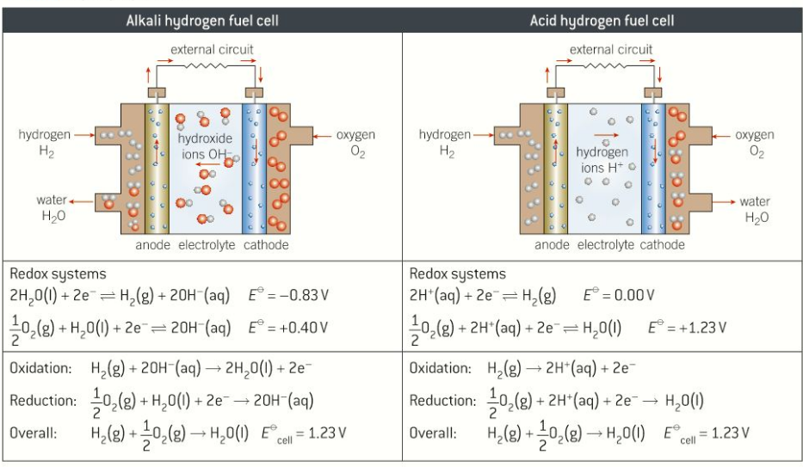

Question 1:
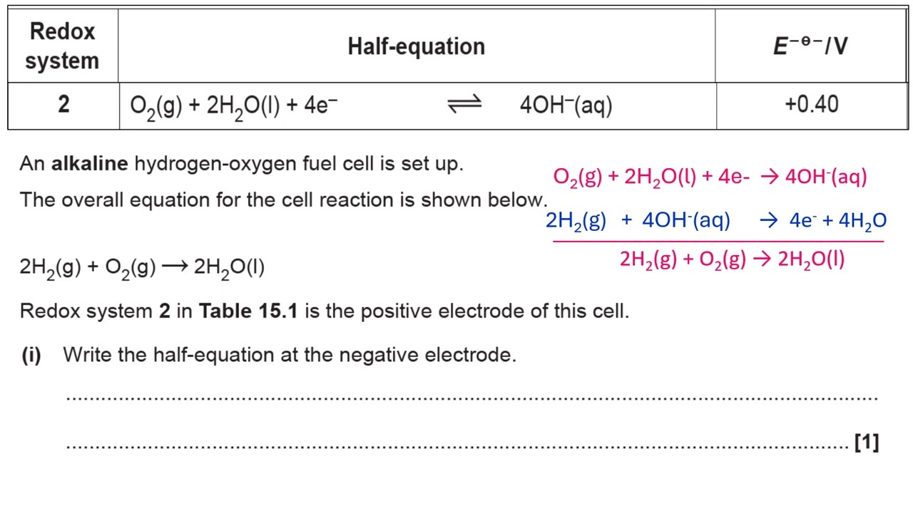

Question 2:

A proton-exchange membrane (PEM) fuel cell uses pure hydrogen gas as the fuel and a proton exchange membrane as the electrolyte.
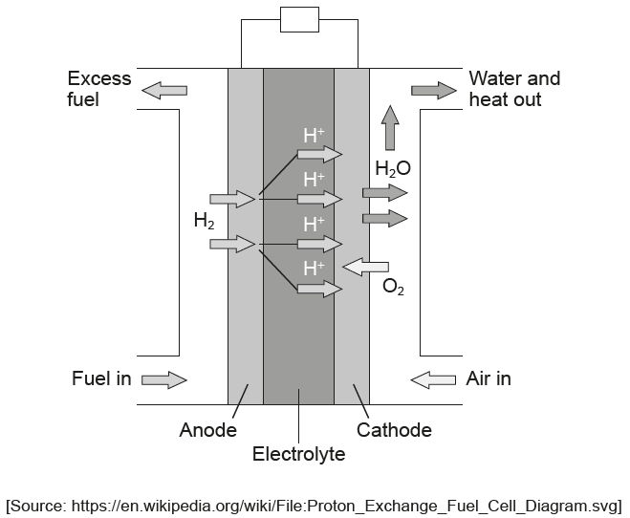

(a) Deduce the half-equations for the reactions occurring at the electrodes. [2]

Anode (negative electrode):
Cathode (positive electrode):
(b(i)) Calculate the cell potential, Eθ, in V, using section 24 of the data booklet. [1]

(c) Suggest an advantage of the PEM fuel cell over the lead-acid battery for use in cars. [1]

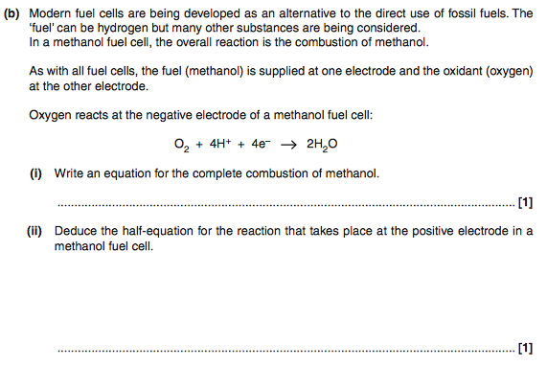
Question 3:

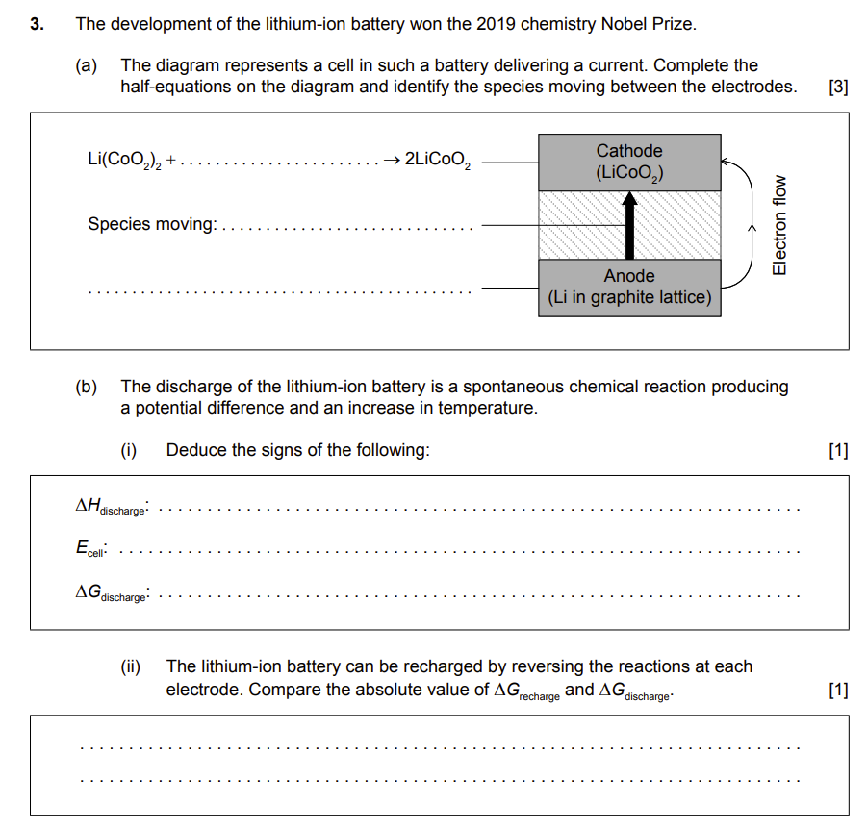
Question 4:

