Title-
Using Calorimetry to Determine the Enthalpy of Formation of Magnesium Oxide Lab

Background-
A calorimeter is a device that is commonly used in chemistry labs to measure the amount of heat absorbed or released during a chemical (or physical) process. Or, in other words, calorimeters measure the enthalpy change of a reaction. Ultimately, if the enthalpy of the system decreases over the reaction (as shown by a calorimeter), it is considered favorable (Science Direct). Calorimeters prejudice this measurement by utilizing the principle of heat transfer, one that transfers the heat from the system to the surroundings (or the other way around). However, before that exact amount of enthalpy can be known, the heat capacity of a calorimeter must first be determined (LibreTexts).
The heat capacity of a calorimeter can be determined by dividing the energy that is introduced by the temperature change introduced. Then, the enthalpy of various reactions can be calculated from the known heat capacity of the calorimeter in formulas such as these (STUDY):
Ccal = qcal / ΔT
While a premade lab-grade calorimeter can be used in enthalpy experiments, another common method of measuring enthalpy is to use styrofoam cups as they are good insulators that can produce accurate results. That enthalpy change that is measured by calorimeters in reactions is commonly denoted as ΔH, or the heat effect for a chemical reaction. This heat effect is measured at a constant pressure (KBCC).
The enthalpies of formation, represented by ΔHf, are specifically the enthalpy changes that happen when one mole of a compound is formed from its component elements in their standard states and they provide a reference point for calculating the enthalpy changes of reactions. The enthalpy change can also show what type of reaction is occurring. Exothermic reactions release heat to the surroundings and so have a negative enthalpy change (ΔH<0), but endothermic reactions absorb heat and so have a positive enthalpy change (ΔH>0) (Britannica).
Some reactions could have an enthalpy of zero, where the reaction to produce the product is neither exothermic nor endothermic. An example of this is the standard enthalpy for the formation of all chemical elements, as there is no energy change involved in forming that substance in its reference state. This is the case for oxygen gas, solid carbon (in the form of graphite), or magnesium metal (TutorChase). But, those reactions that do have an enthalpy change have an accepted enthalpy value that chemists can use as reference points for their chemical reactions done in a calorimeter (FSU).
However, some compounds such as MgO (magnesium oxide) have very difficult enthalpies of formation to measure. This is due to the high reactivity of magnesium and oxygen, and so indirect methods have to be employed to determine that enthalpy value. This can be done with something like Hess’s Law, where that unknown value can be found by combining the known enthalpies of formation for related reactions. This Law is pictured in a way such as this chart, displaying how the reactants and products relate to each other (Khan Academy):
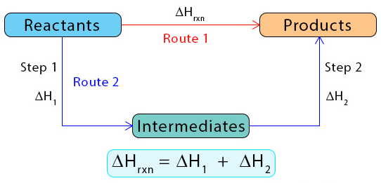
Hess’s Law, therefore, can be used to find the enthalpy of reaction for MgO by using the enthalpy of formation of its components using the following equations:
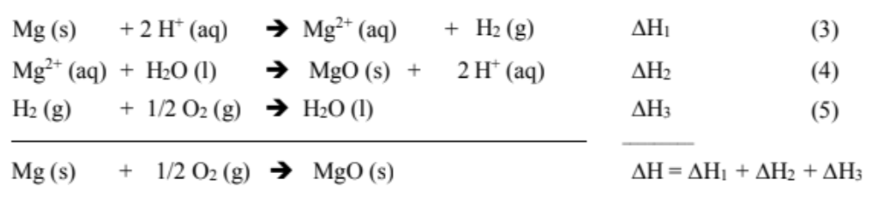
Purpose: To measure the enthalpies of the formation of Mg2+ (aq) and MgO (s).

Research Question-
How can calorimetry be used to determine the enthalpy of the formation of magnesium oxide?

Hypothesis-
The substances dissolved in HCl (the Mg and the MgO) will cause an increase in the enthalpy of formation, which will then in turn cause a temporary and measurable rise in the temperature of the solution.

Variables-
Independent Variables: The substance that is being dissolved in the HCl
Dependent Variables: The enthalpy of that formation
Confounding Variables: Heat loss from the calorimeter (that affects the temperature readings), the efficiency of the apparatuses (whether the calorimeter is properly insulated or materials are properly calibrated), the purity of the reactions tested, sources of human error (from the experimenters), and many more factor relating to the set-up of the experiment
Controls: The stirring rate (constant due to the stir plate), the position of the thermometers (held in place by a burette stand), calorimeter design (this was consistent throughout all of the experiments), the source of the reactants (from the lab instructor), the timer of the experiment, and the same apparatuses were used through all the experiments as well

Materials-
- 2 Styrofoam Cups (at the Least)
- 2 Circle Cardboard Cutouts (with Larger Diameters than the Diameter of the Styrofoam Cups)
- 2 Thermometers
- Magnetic Stir Bar
- Magnetic Stir Plate
- Digital Balance / Scale
- Burette Stand (with an Arm)
- Graduated Cylinder
- Distilled Water
- Electric Kettle
- Weigh Paper
- Funnel
- Beaker (Optional Personal Waste Container)
- Granular Magnesium Metal (Mg)
- Hydrochloric Acid (HCl)
- Magnesium Oxide (MgO)

Procedures-
Note: When cleaning out the calorimeters or any apparatuses that HCl has touched, make sure to not clean them out into a sink drain. This is because HCl is an acid and could affect local environments if released into the drain, maybe sure to dispose of the acid as the lab instructor dictates.
Note: For ease of use and more accuracy, the thermometer used for the calorimeter can be set up over the styrofoam cup with a burette stand rather than being held directly by an experimenter.
Note: Obtain the hot water for the calorimeter from the lab instructor, who heated it up properly with an eclectic kettle.

Heat Capacity of Calorimeter:
- Obtain a styrofoam cup and cardboard. Trace out a lid for the respective cup on the cardboard and cut it out to fit properly. Make a hole in the cardboard lid large enough to fit a thermometer. Place an empty weigh paper and magnetic stir bar into the cup and place the lid on. Insert a thermometer into the lid’s hole. Repeat this process to end up with two calorimeters, each similar to the one illustrated in Figure 1 (pictured below).
- Note: Two thermometers are needed for this experiment, as each calorimeter needs its respective thermometer.
- To compare the reading of the two thermometers for the separate calorimeters, immerse them together in room temperature distilled water for one minute. Once the minute has passed, read the temperature to the nearest 0.10C for each thermometer. Record those temperatures.
- Note: Make sure to read the thermometer properly to avoid parallax in your readings. Record the temperatures from the bottom of the meniscus.
- Once the thermometers are compared, set them up in their respective calorimeters. Add another insulated styrofoam cup to the hot calorimeter, so that the calorimeter for the hot water will properly hold the heat.
- Note: If there is a measurement difference between the two thermometers, apply the corrections to all readings of the hot water thermometer to correspond with the cold water thermometer readings (so they will all correspond).
- Note: From this point on in the experiment, make sure to always use the same thermometer that’s in the cold water in the cold calorimeter. Always make sure to use the same thermometer that’s in the warm water in the warm calorimeter.
- Note: To have a clear difference between the room temperature-water calorimeter and the hot-water calorimeter, from now on, the room temperature-water calorimeter will be referred to as the cold calorimeter.
- To find the heat that is lost to the calorimeter, place 100.0cm^3 of room temperature in one calorimeter and 100.0cm^3 of hot water (that is about 20.0-25.0℃ above the room temperature water) in the other calorimeter. Place the cold calorimeter with the room temperature water on a stir plate. Once the lids and thermometers are in place, take careful temperature readings of each calorimeter after one minute has passed. Turn on the stir plate.
- When the readings are taken and recorded, pour the hot water quickly from the hot calorimeter to the cold calorimeter. Once the water has mixed for about 15-30 seconds, record the maximum temperature using the thermometer from the cold water calorimeter.
- Calculate the heat lost by the warm water and the heat gained by the cold water.
- Note: Make sure that the stir plate is stirring the mixed water with the stirring magnet.
- Note: To calculate the heat lost by the warm water and the heat gained by the cold water, use this formula: mass H2O × specific heat × ∆T. You can assume that the density of water is 1.0 g cm-3, and the specific heat of water is 4.184 J g-1 ℃-1. The result simply measures the amount of heat required to raise the temperature of the entire calorimeter setup (shown in Figure 1) by 1.0℃.
- Repeat steps 4 through 6 and once again calculate the heat capacity of the calorimeter. Then, average the two values obtained.

Reaction #1 for Equation #3 (pictured in Figure 2):
- Use an analytical balance to weigh out 0.4800 ± 0.01g of granular magnesium metal into a tared weighing paper. Assemble just a single calorimeter on top of a magnetic stir plate.
- Note: Assemble the calorimeter as you did in Step 1 of “Heat Capacity of Calorimeter” in the first part of this experiment. Use Figure 1 for a reference.
- Note: Make sure to check the demonstration set-up in the lab before you begin.
- Fill your calorimeter with 100 cm3 of 0.500 mol dm-3 HCl and start stirring. Measure the temperature in 30-second intervals for two minutes. Record those intervalled readings in a chart.
- Add the Mg with the weighing paper and continue to measure the temperature over 30-second intervals until the temperature passes a plateau. Continue to record the temperatures in 30-second intervals past the plateau once the temperature readings begin to drop (as shown in Figure 3).
- Note: Make sure to take at least four different temperature measurements (do not have to be concordant) past the plateau point (highest temperature reading). Make sure each of those successive temperature measurements is lower in temperature than the previous reading.
- Note: Make sure to add the weighing paper to the calorimeter with the Mg, as if you do not, the temperature readings will have more errors. The magnetic stir bar and the weighing paper will not affect the readings as they were accounted for in measuring the heat capacity of the calorimeter part of the experiment.

Reaction #2 for the Reverse of Equation #4 (pictured in Figure 2):
- Tare a clean weighing paper. To this add approximately as many moles (±2%) of MgO as you weighed of Mg for reaction #1. Record the mass accurately to four decimal places.
- Note: The molar weight of MgO is equal to 40.30g mol^-1.
- Note: If 0.4800 ± 0.01 g of Mg was used in “Reaction #1”, then 0.8000 ± 0.01 g of MgO will be used in “Reaction #2”.
- Clean the calorimeter from “Reaction #1” out and place it back on the magnetic stirring plate. Add 100 cm3 of 0.500 mol dm-3 HCl and start stirring. Measure the temperature in 30-second intervals for two minutes. Record those intervalled readings in a chart.
- Note: Make sure to use the exact same calorimeter for “Reaction #2” that was used in “Reaction #1”.
- Add the MgO with the weighing paper and continue to measure the temperature over 30-second intervals until the temperature passes a plateau. Continue to record the temperatures in 30-second intervals past the plateau once the temperature readings begin to drop (as shown in Figure 3).
- Note: Make sure to take at least four different temperature measurements (do not have to be concordant) past the plateau point (highest temperature reading). Make sure each of those successive temperature measurements is lower in temperature than the previous reading.
- Note: Make sure to add the weighing paper to the calorimeter with the MgO, as if you do not, the temperature readings will have more errors. The magnetic stir bar and the weighing paper will not affect the readings as they were accounted for in measuring the heat capacity of the calorimeter part of the experiment.

Figure 1: Diagram of the styrofoam cup calorimeter.
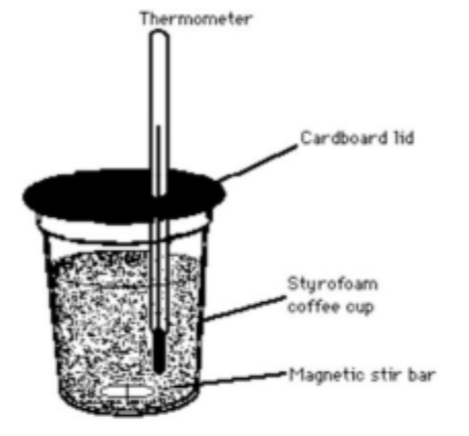

Figure 2: The reaction equations that “Reaction #1” and “Reaction #2” are based on.

Figure 3: Graphical method of calculating corrected temperature rise.
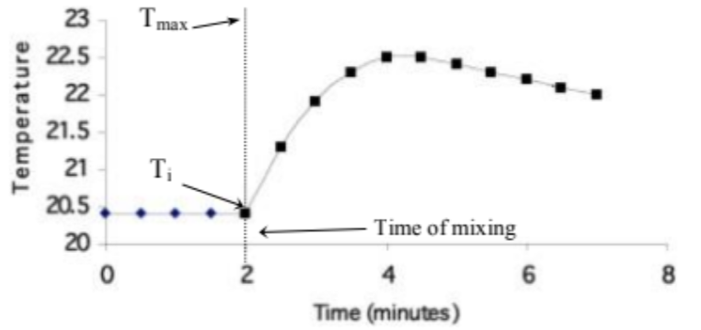

Experimental Setup-
Figures 4, 5, and 6 (pictured in their respective order): The setup of the calorimeter experiment.
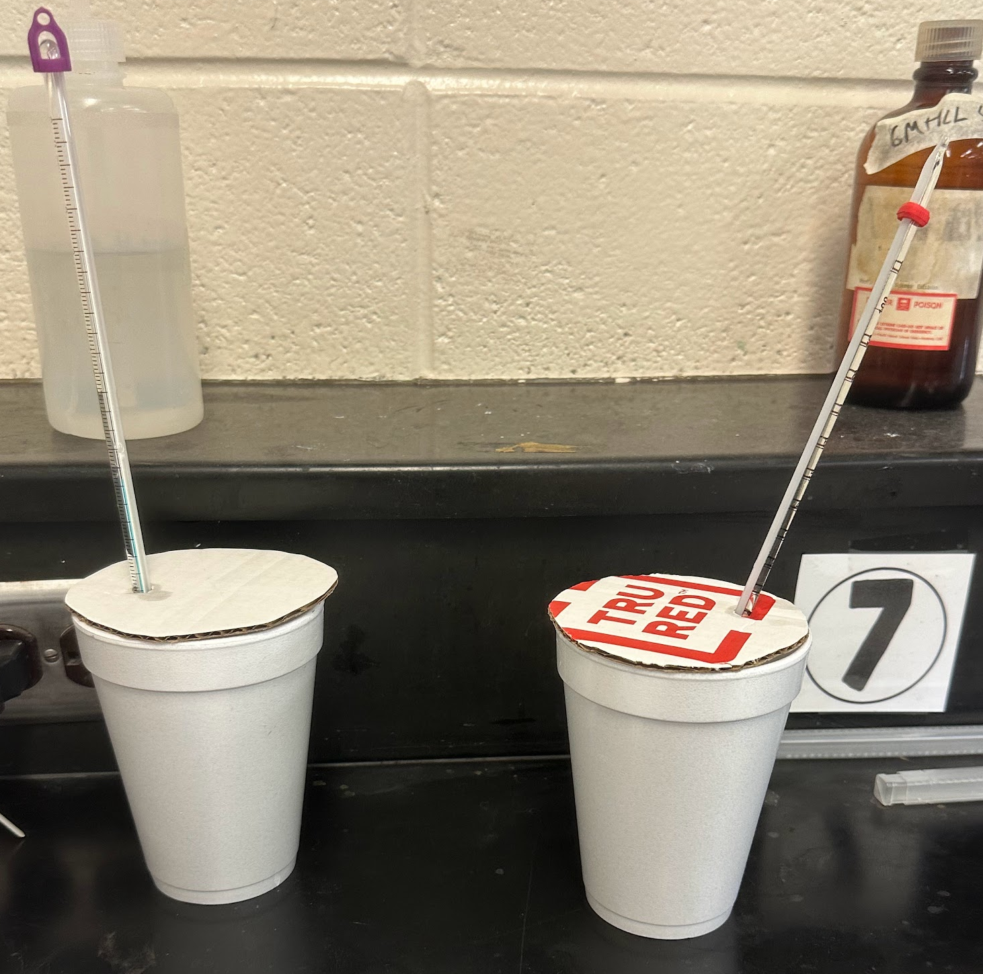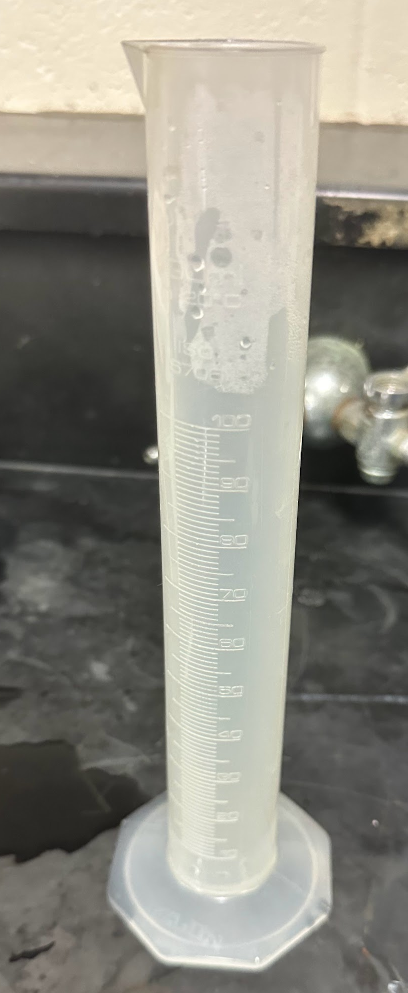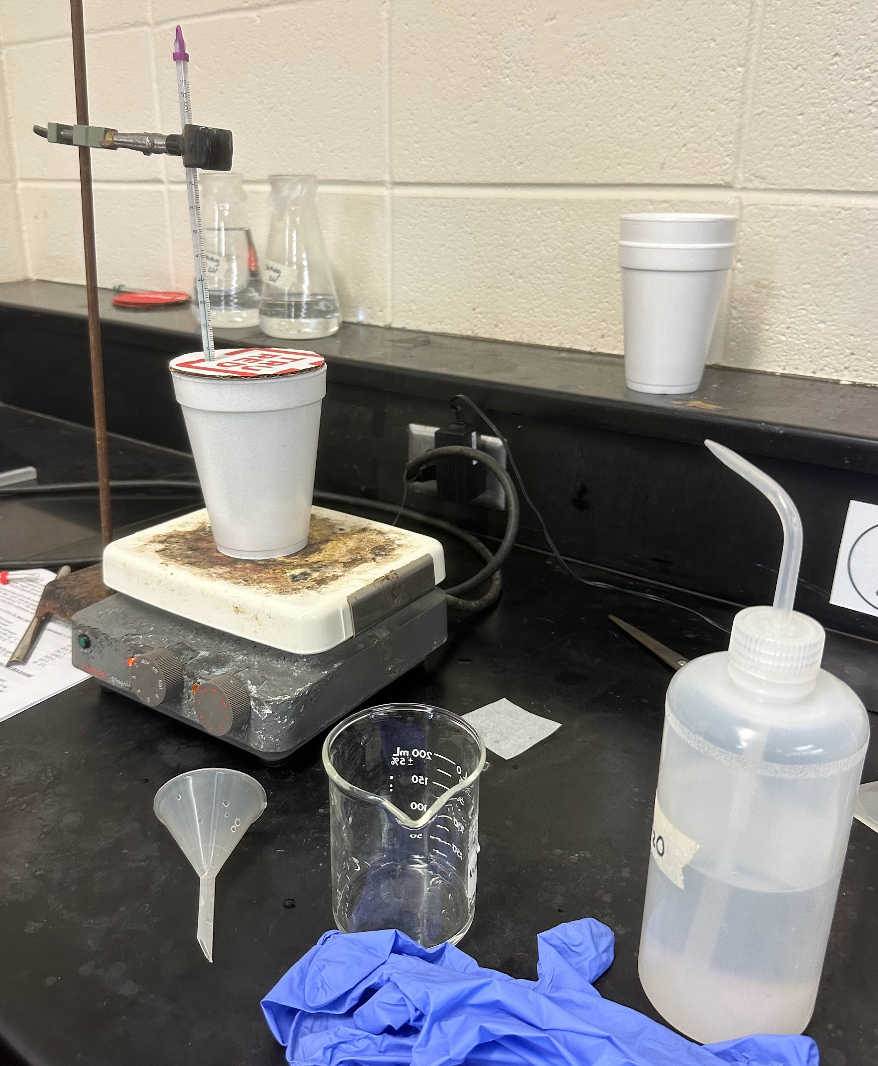
Figure 4 depicts the two calorimeters used in the “Finding the Heat Capacity of the Calorimeter'' part of the experiment. The styrofoam cups contain a weigh paper and a magnetic stir rod, covered by a cardboard lid with a hole in it for a thermometer. The calorimeter with the purple-tipped thermometer was for cold water, and the calorimeter with the red-tipped thermometer was for hot water. Figure 5 depicts the HCl being measured out to its appropriate amount for the Mg and MgO enthalpy experiments. It was also used to measure the cold water and hot water in the “Finding the Heat Capacity of the Calorimeter'' part of the experiment. Figure 6 depicts the distilled water in its bottle (to the right of the photo) that was used to clean the apparatuses. The funnel in the front was used to transfer the water and acid into the graduated cylinder for measurement. The built calorimeter is also pictured on the stir plate, which is on and stirring. The burette stand has been positioned so that the thermometer can be held above the calorimeter steadily (but is positioned to not touch the magnetic stir bar or the styrofoam cup).

Raw Data-
The Temperature of the Water Measured in the Calorimeter:

Entry: | Trial 1: | Trial 2:
Starting Temperature of 100cm³ of Hot Water - | 73.0 ± 0.05℃ | 62.0 ± 0.05℃
Starting Temperature of 100cm³ of Cold Water - | 22.0 ± 0.05℃ | 22.0 ± 0.05℃

Temperature Change Over Time of the HCl and Mg Mixture:
Note: The first 2 minutes of recorded temperatures were without the Mg being added to the HCl to establish a baseline temperature, which is reflected in the graph created from this data in the data analysis section.
Time Elapsed (in seconds) | 0 sec | 30 sec | 60 sec | 90 sec | 120 sec
Temperature in Celsius (with uncertainty of ± 0.05) | 21.0 ± 0.05℃ | 21.0 ± 0.05℃ | 21.0 ± 0.05℃ | 21.0 ± 0.05℃ | 21.0 ± 0.05℃

Time Elapsed (in seconds) | 150 sec | 180 sec | 210 sec | 240 sec | 270 sec | 300 sec | 330 sec | 360 sec | 390 sec
Temperature in Celsius (with uncertainty of ± 0.05) | 22.0 ± 0.05℃ | 28.0 ± 0.05℃ | 31.5 ± 0.05℃ | 32.5 ± 0.05℃ | 33.0 ± 0.05℃ | 33.0 ± 0.05℃ | 33.0 ± 0.05℃ | 33.0 ± 0.05℃ | 33.0 ± 0.05℃

Time Elapsed (in seconds) | 420 sec | 450 sec | 480 sec | 510 sec | 540 sec | 570 sec | 600 sec | 630 sec | 660 sec
Temperature in Celsius (with uncertainty of ± 0.05) | 33.0 ± 0.05℃ | 33.0 ± 0.05℃ | 32.5 ± 0.05℃ | 32.5 ± 0.05℃ | 32.0 ± 0.05℃ | 32.0 ± 0.05℃ | 32.0 ± 0.05℃ | 32.0 ± 0.05℃ | 32.0 ± 0.05℃

Time Elapsed (in seconds) | 690 sec | 720 sec | 750 sec | 780 sec
Temperature in Celsius (with uncertainty of ± 0.05) | 31.9 ± 0.05℃ | 31.9 ± 0.05℃ | 31.9 ± 0.05℃ | 31.8 ± 0.05℃

Temperature Change Over Time of the HCl and MgO Mixture:
Note: The first 2 minutes of recorded temperatures were without the MgO being added to the HCl to establish a baseline temperature, which is reflected in the graph created from this data in the data analysis section.
Time Elapsed (in seconds) | 0 sec | 30 sec | 60 sec | 90 sec | 120 sec
Temperature in Celsius (with uncertainty of ± 0.05) | 20.1 ± 0.05℃ | 20.1 ± 0.05℃ | 20.1 ± 0.05℃ | 20.1 ± 0.05℃ | 20.1 ± 0.05℃

Time Elapsed (in seconds) | 150 sec | 180 sec | 210 sec | 240 sec | 270 sec | 300 sec | 330 sec | 360 sec | 390 sec
Temperature in Celsius (with uncertainty of ± 0.05) | 21.2 ± 0.05℃ | 22.7 ± 0.05℃ | 23.0 ± 0.05℃ | 23.0 ± 0.05℃ | 23.0 ± 0.05℃ | 23.0 ± 0.05℃ | 23.0 ± 0.05℃ | 23.0 ± 0.05℃ | 23.0 ± 0.05℃

Time Elapsed (in seconds) | 420 sec | 450 sec | 480 sec | 510 sec | 540 sec | 570 sec | 600 sec | 630 sec | 660 sec
Temperature in Celsius (with uncertainty of ± 0.05) | 23.0 ± 0.05℃ | 23.0 ± 0.05℃ | 23.0 ± 0.05℃ | 23.0 ± 0.05℃ | 23.0 ± 0.05℃ | 23.0 ± 0.05℃ | 23.0 ± 0.05℃ | 23.0 ± 0.05℃ | 23.0 ± 0.05℃

Time Elapsed (in seconds) | 690 sec | 720 sec | 750 sec | 780 sec | 810 sec | 840 sec | 870 sec | 900 sec | 930 sec
Temperature in Celsius (with uncertainty of ± 0.05) | 23.0 ± 0.05℃ | 23.0 ± 0.05℃ | 23.0 ± 0.05℃ | 23.0 ± 0.05℃ | 23.0 ± 0.05℃ | 23.0 ± 0.05℃ | 23.0 ± 0.05℃ | 23.0 ± 0.05℃ | 23.0 ± 0.05℃

Time Elapsed (in seconds) | 960 sec | 990 sec | 1020 sec | 1050 sec | 1080 sec | 1110 sec | 1140 sec | 1170 sec | 1200 sec
Temperature in Celsius (with uncertainty of ± 0.05) | 23.0 ± 0.05℃ | 23.0 ± 0.05℃ | 23.0 ± 0.05℃ | 22.9 ± 0.05℃ | 22.9 ± 0.05℃ | 22.9 ± 0.05℃ | 22.9 ± 0.05℃ | 22.9 ± 0.05℃ | 22.8 ± 0.05℃

Time Elapsed (in seconds) | 1230 sec | 1260 sec | 1290 sec | 1320 sec | 1350 sec | 1380 sec
Temperature in Celsius (with uncertainty of ± 0.05) | 22.8 ± 0.05℃ | 22.8 ± 0.05℃ | 22.8 ± 0.05℃ | 22.7 ± 0.05℃ | 22.7 ± 0.05℃ | 22.6 ± 0.05℃

Data Analysis-
The calculations below show how we calculated heat lost to our calorimeter, heat capacity of the calorimeter (heat lost to calorimeter / Twater - Twater cold), enthalpy change per mole of a reaction, our % accuracy, etc.. To form a set up for an ideal comparison between the two, we kept the mass solid and solution constant. We wanted to calculate the enthalpy changes of 0.48 g of Mg added to 100.0 cm^3 and 0.48 g of MgO added to 100.0 cm^3. To calculate the enthalpy change of Mg in HCl, first we found the mass of solid in grams: 0.4800 g ± 0.0200 g. Then we wanted to calculate the percent uncertainty, which we did by taking our uncertainty of 0.0200 and dividing it by 0.4800. We multiplied this by 100 for a percent and we got 4.2% as our result. Next, we needed to calculate the mass of our solid and solution in grams. We took our 0.4800 g and added it to 119.10 g HCl (the accepted value of 100 cm^3 of HCl), giving us 119.5800 g. Again, we made sure to include our uncertainties, both absolute and percent: 0.0200 g + 0.01 g = 0.03 g; (0.03 / 119.5800) x 100 = 0.025%. Then we calculated our change in temperature by taking our maximum temperature reading from adding Mg to HCl, which was 32.5 degrees Celsius, and subtracting the initial temperature reading, which was 21.0 degrees Celsius (giving us 11.5 degrees Celsius). We calculated our uncertainties in the same pattern as before and got ± 0.1 degrees Celsius or 0.87%. Next it was time to calculate the enthalpy of the reaction in Joules: -(0.0101 g/cm^3 x 4.07 J/g degrees Celsius x 11.5 degrees Celsius), which gave us -0.4727305 J, or -.000473 kJ. And finally to calculate enthalpy change per mole, we took 0.48 g Mg x (1 mol / 24.305 g) and got about 0.020 mol Mg. We then took our calculated enthalpy of -.4727305 J and divided it by our number of moles (0.0197490228). The resulting answer was -23.936 J/mol Mg or -0.0239 kJ/mol Mg. We then performed the same calculations to find the results of the MgO and HCl reaction. Our calculated enthalpy was -0.1192103 J or -0.000119 kJ. We then performed the mass/mole conversion and used our resulting 0.012 mol MgO to calculate the enthalpy change of the reaction per mole: -0.1192103 J / 0.0119091924 mol = -10.01 J/mol, or -0.0100 kJ/mol MgO. Our third enthalpy change in reaction was given to us as a constant of -285.8 kJ/mol. With this, we were able to add them all together and get -285.8339 kJ/mol. With these calculations, we were able to determine that our accuracy was 47.5%: (-285.8339 kJ/mol / -601.6 kJ/mol)x100 = 47.5%.

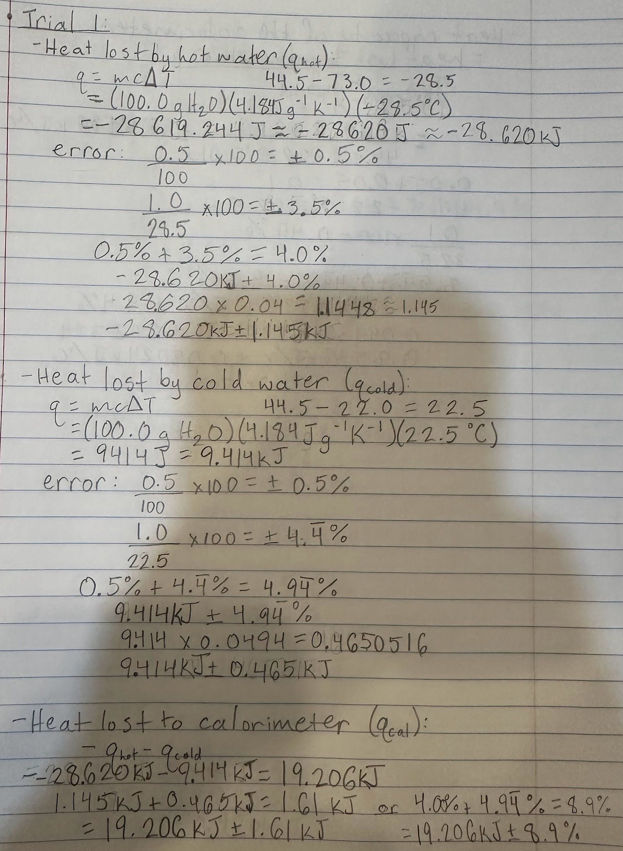
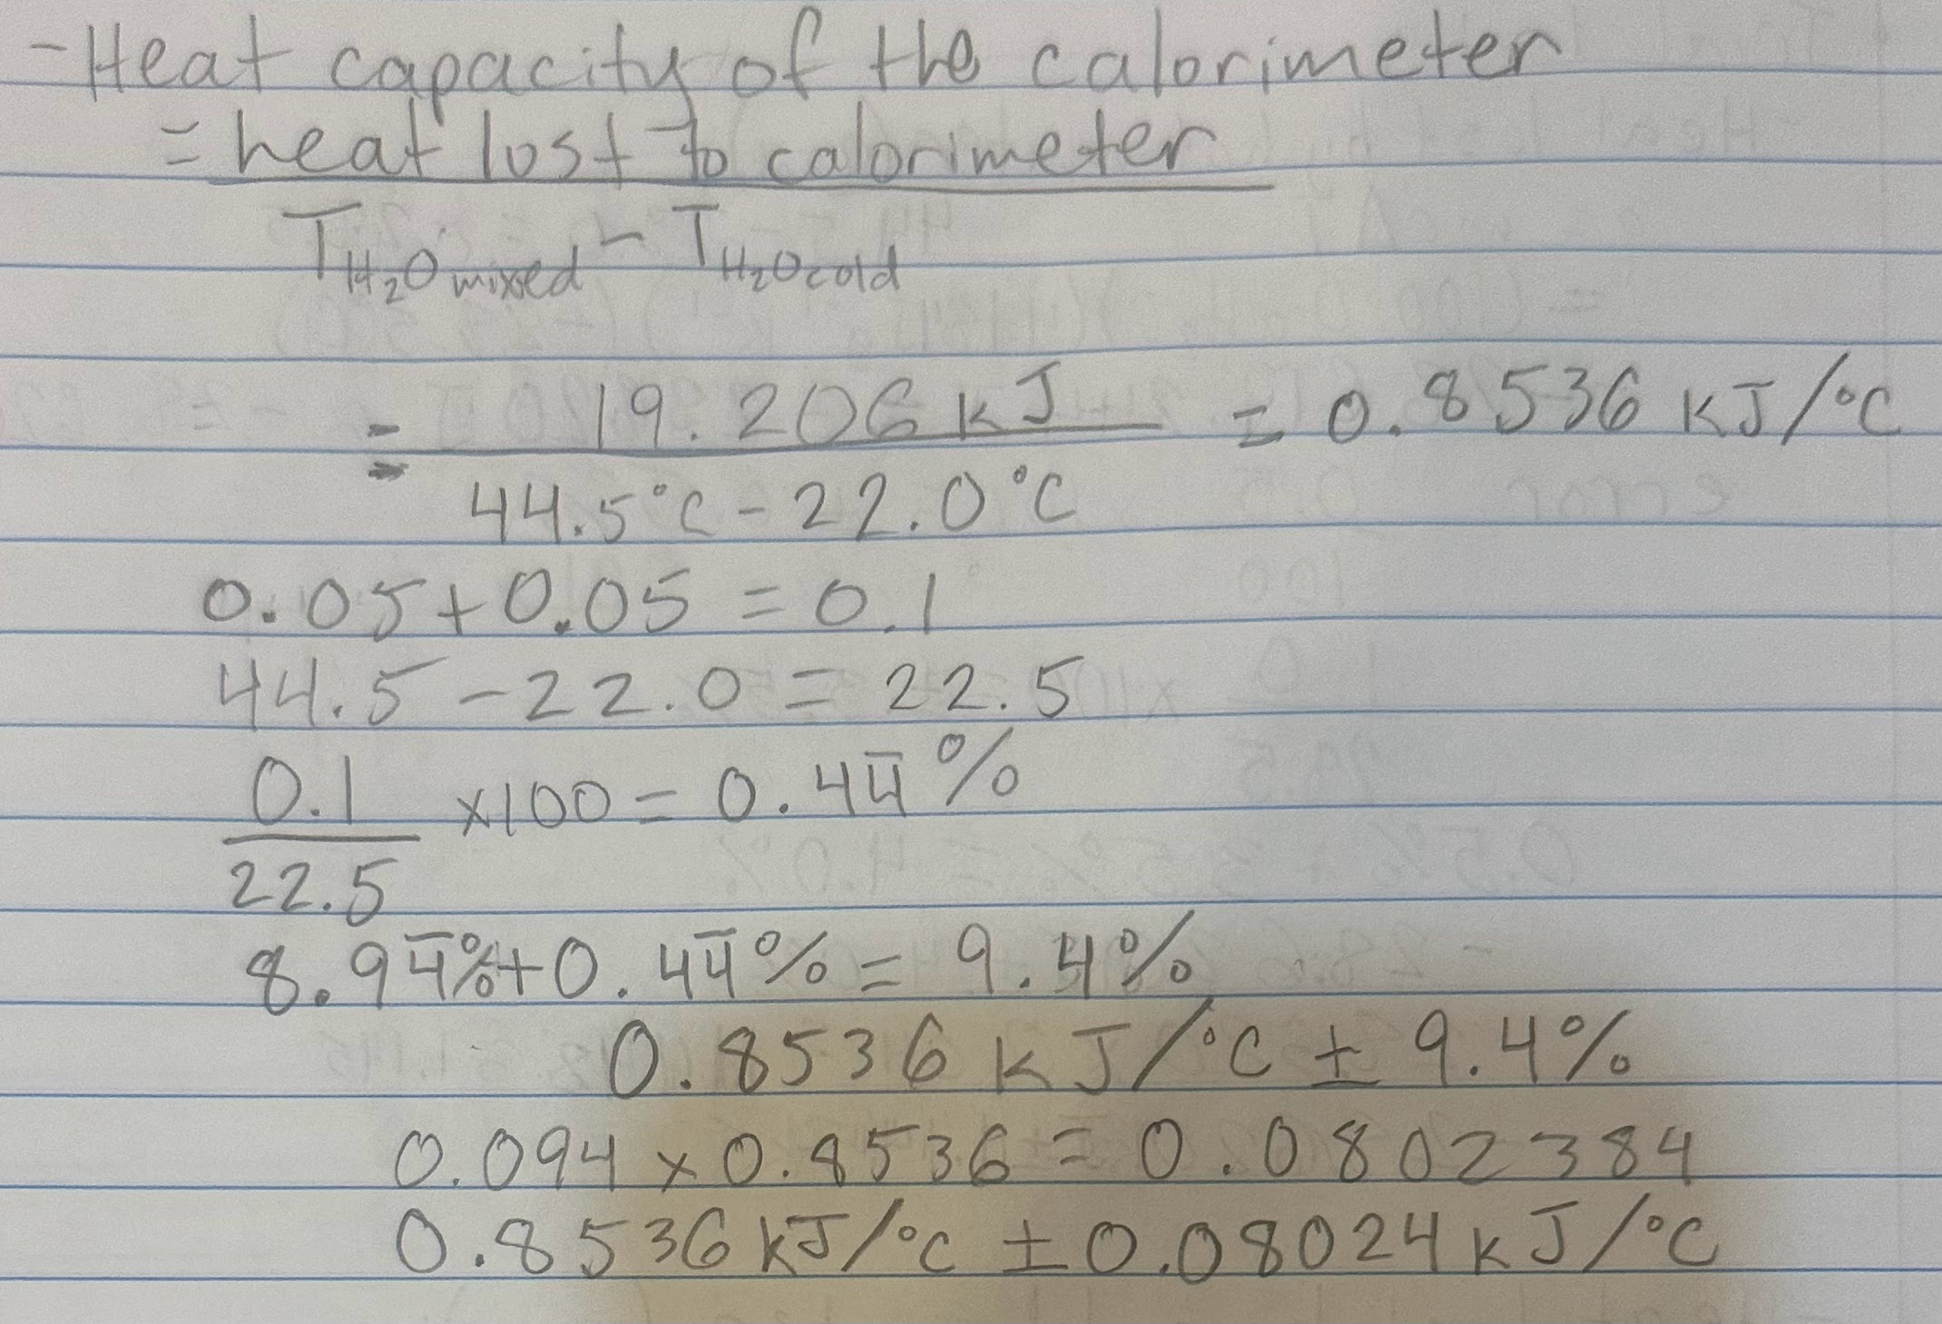
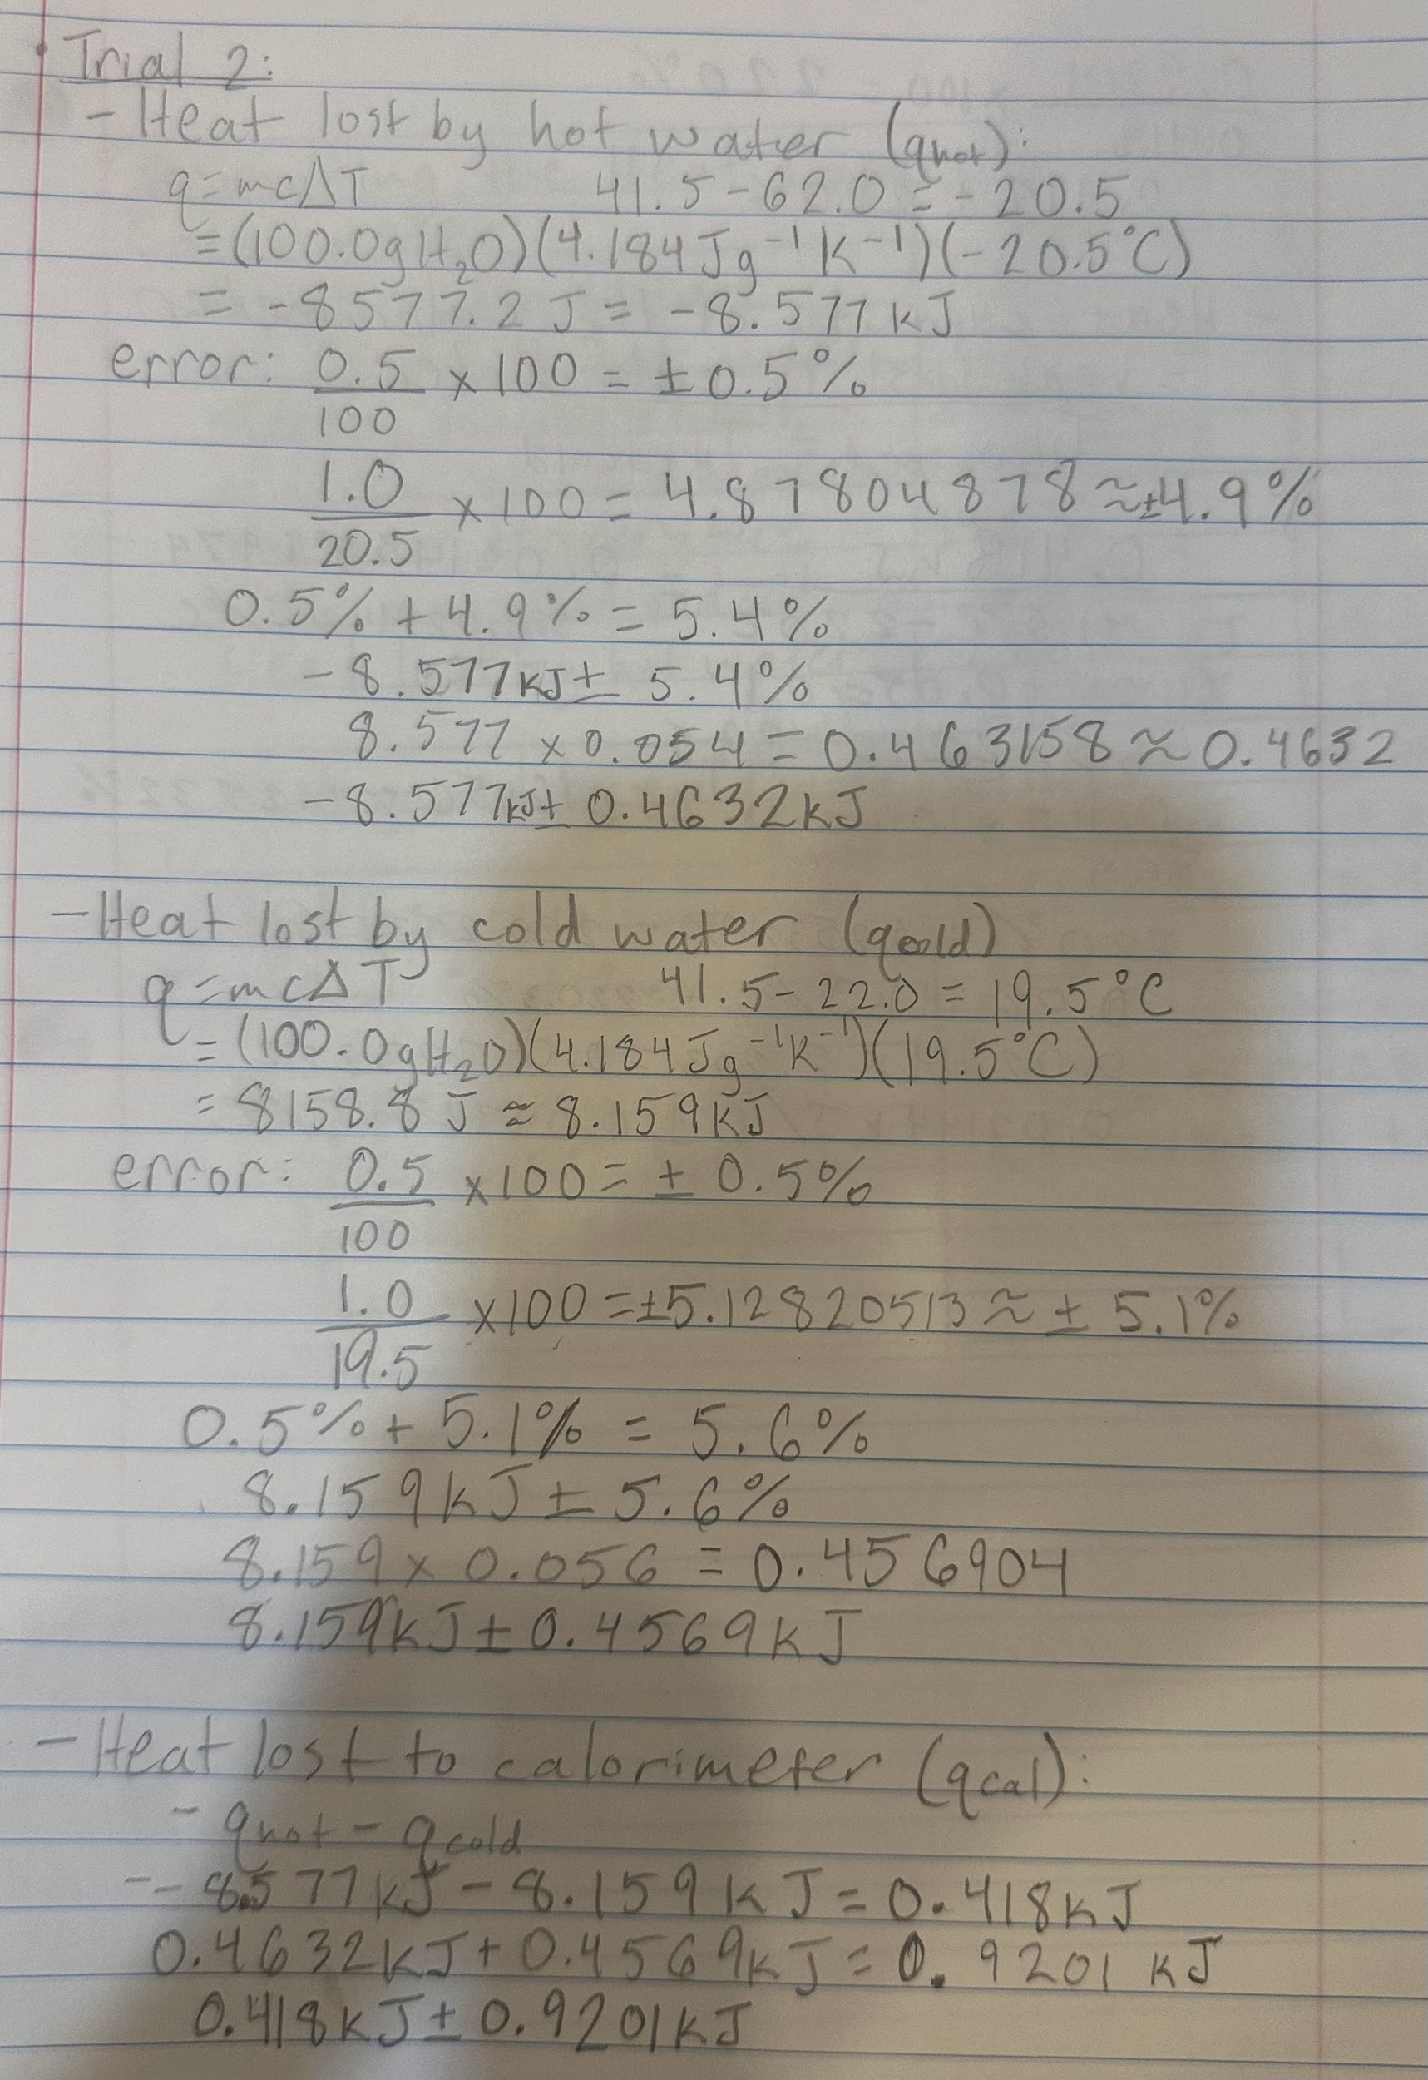
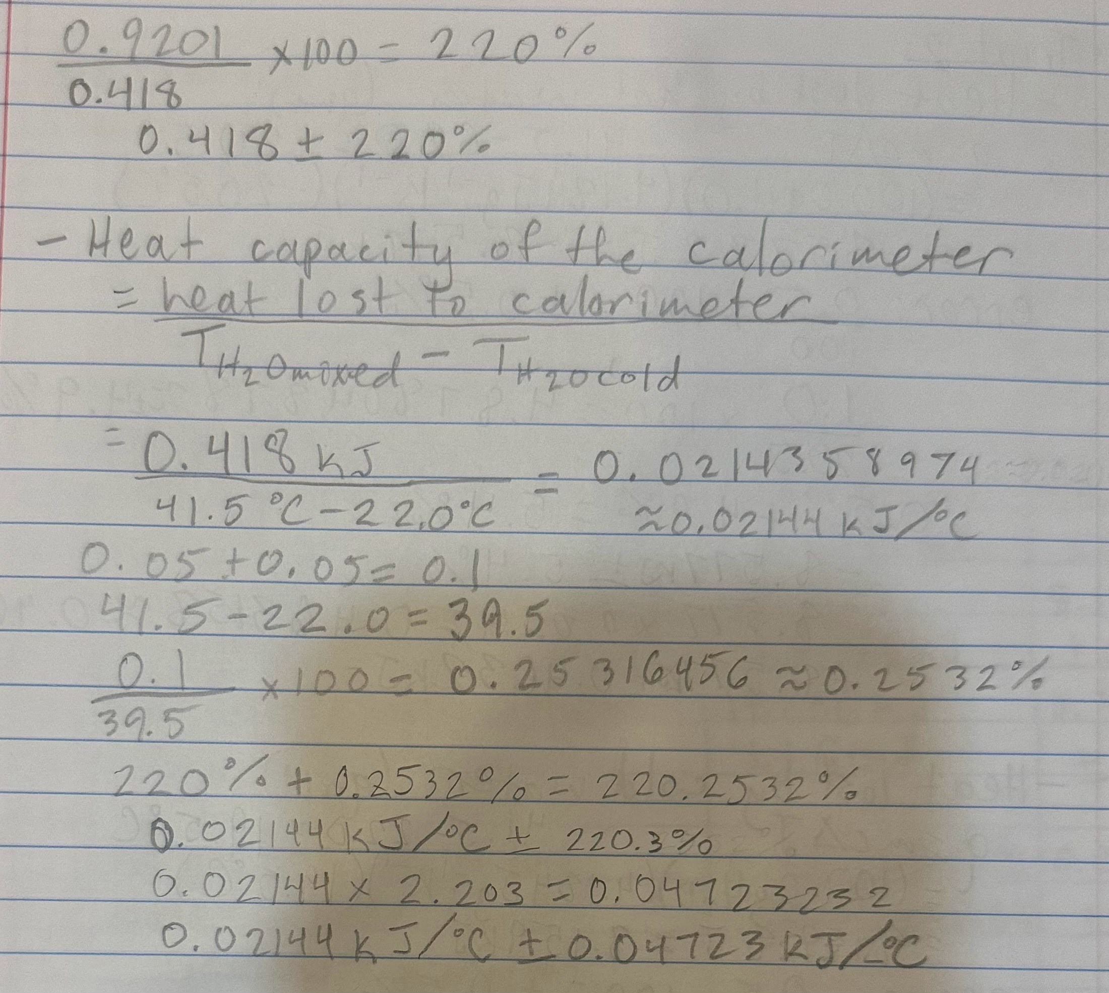
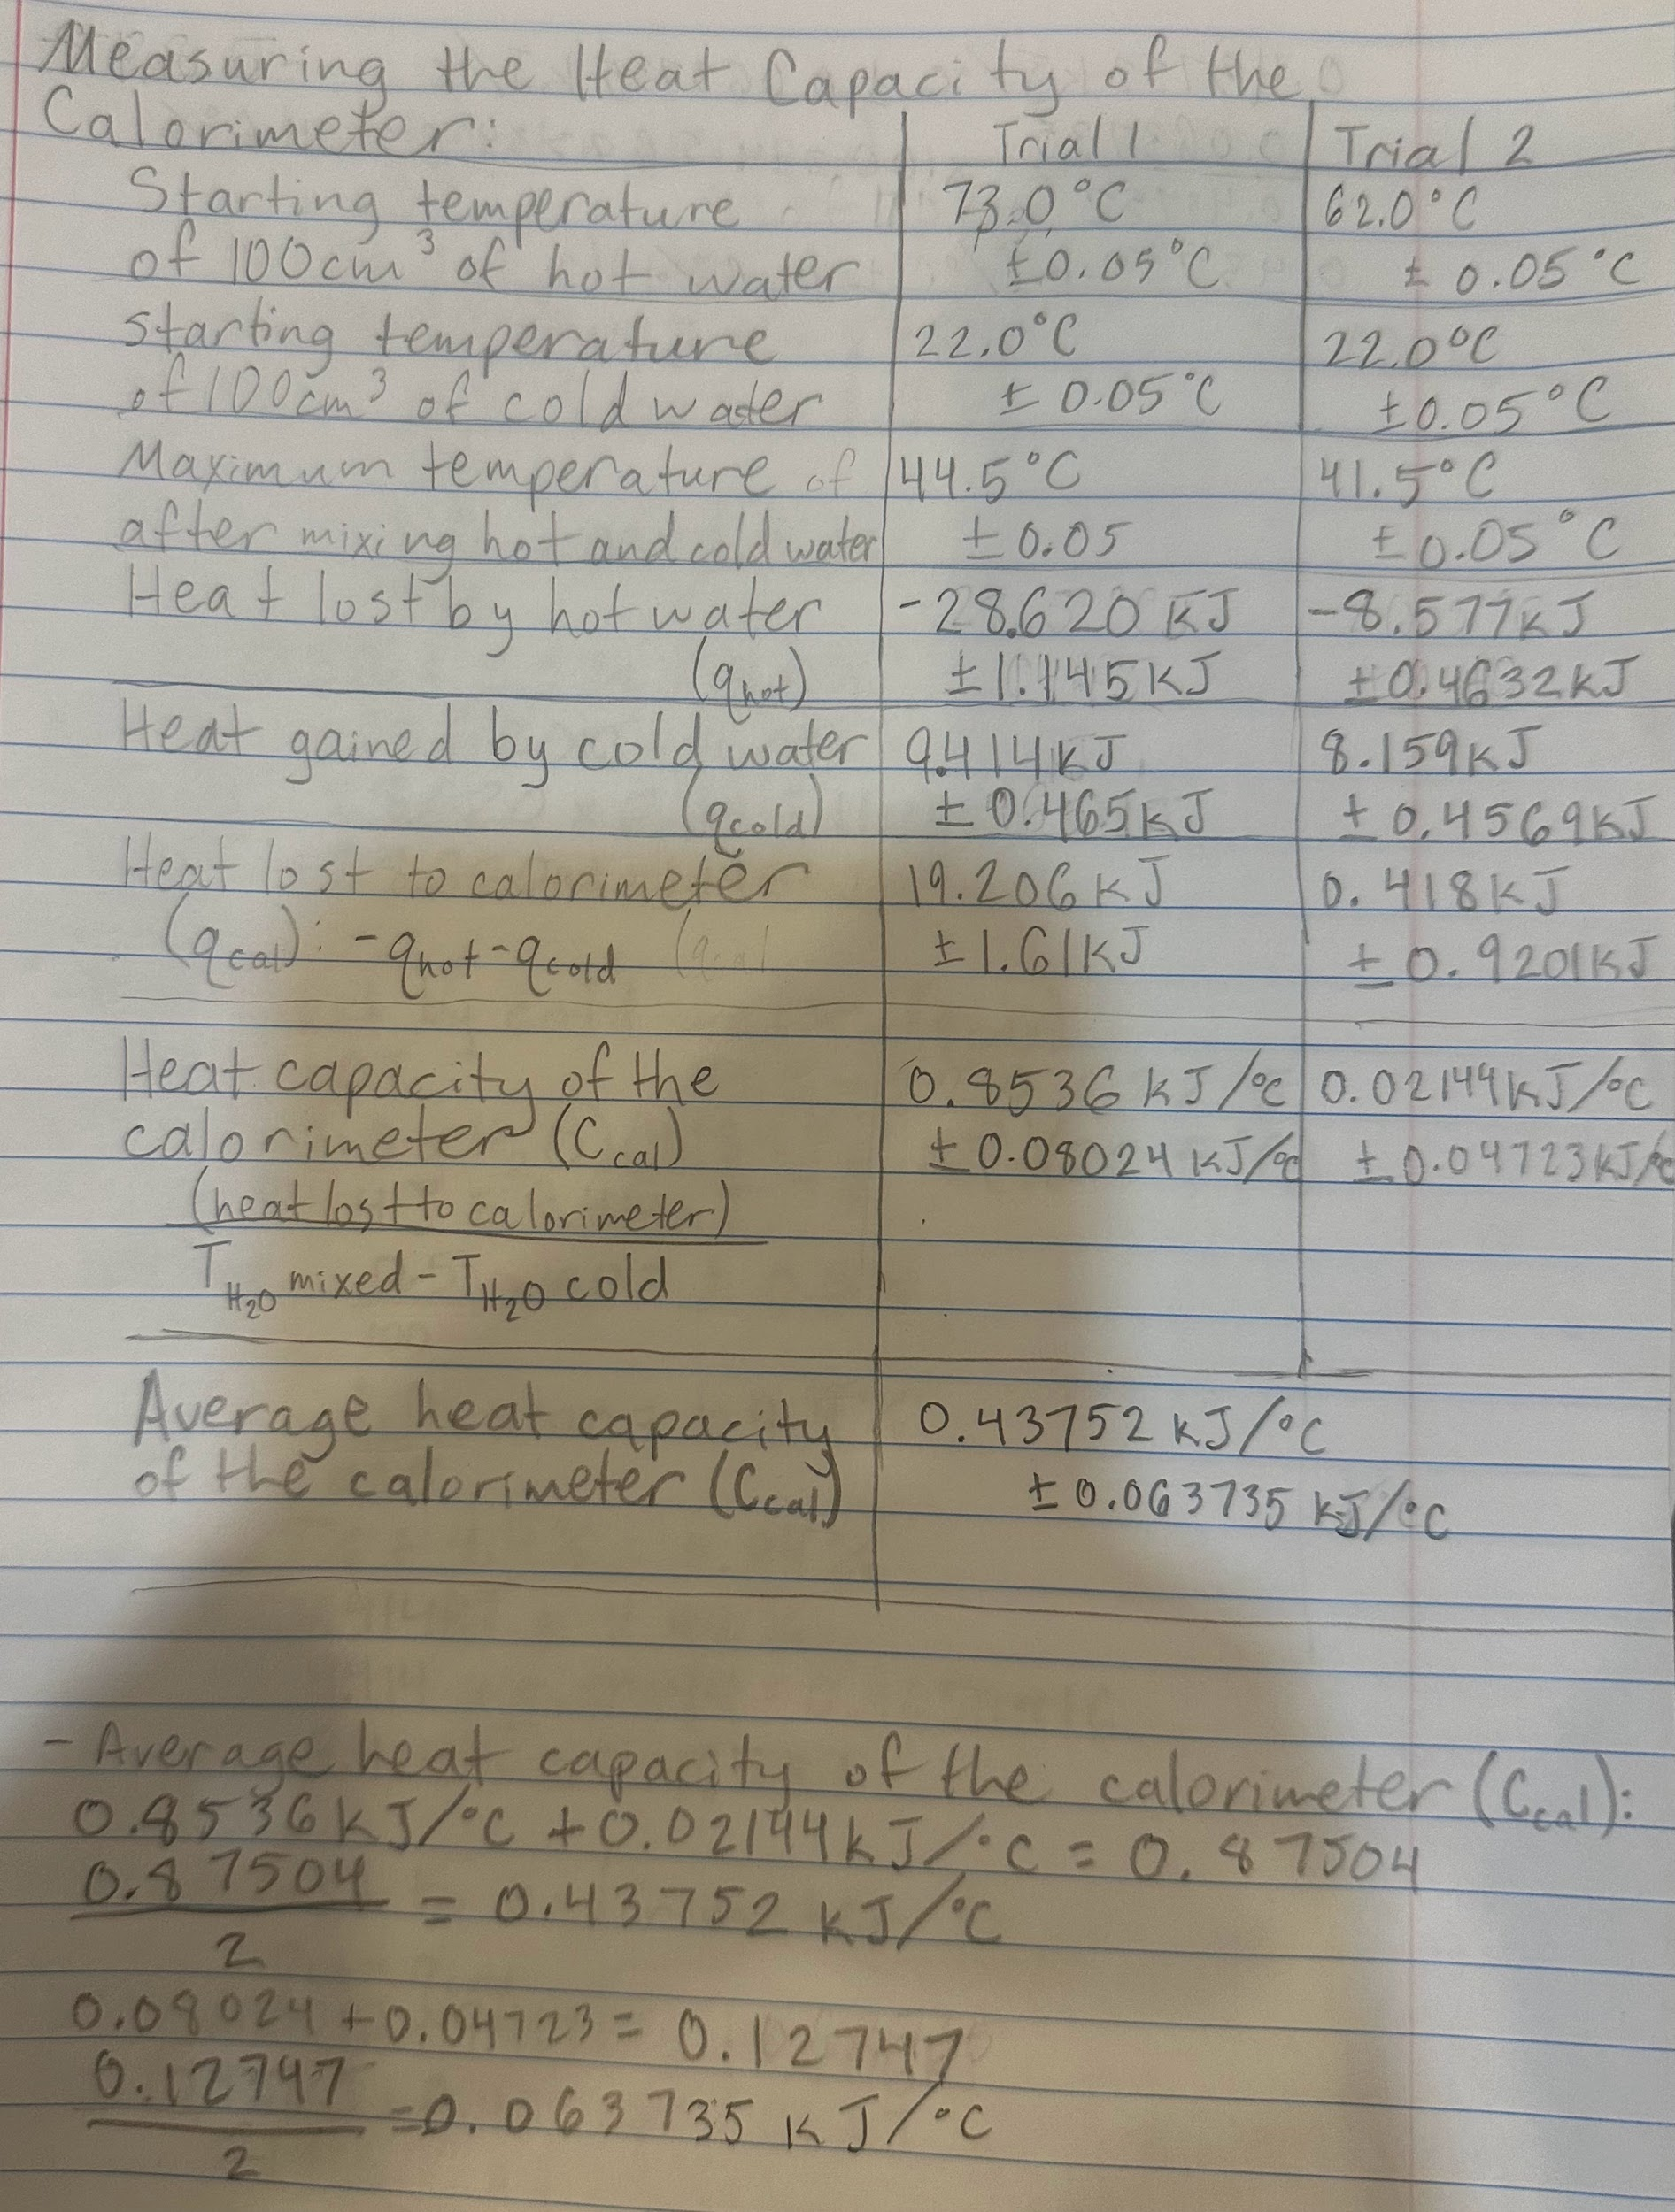
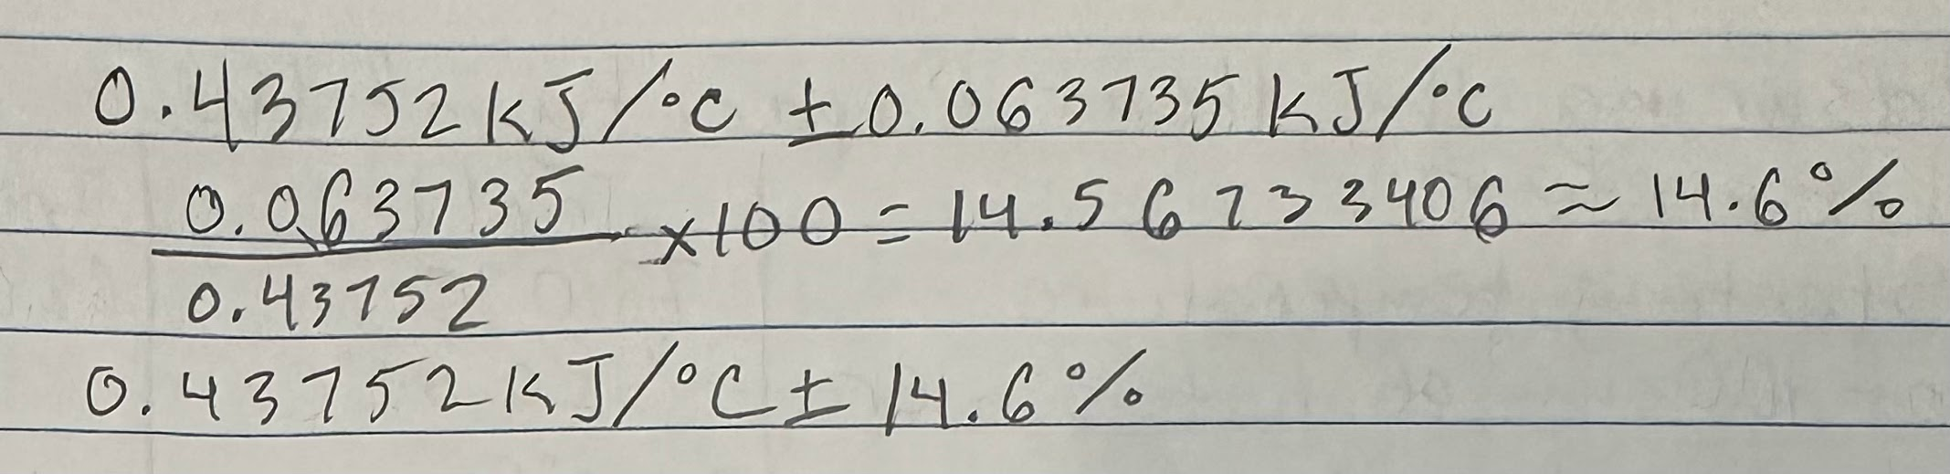
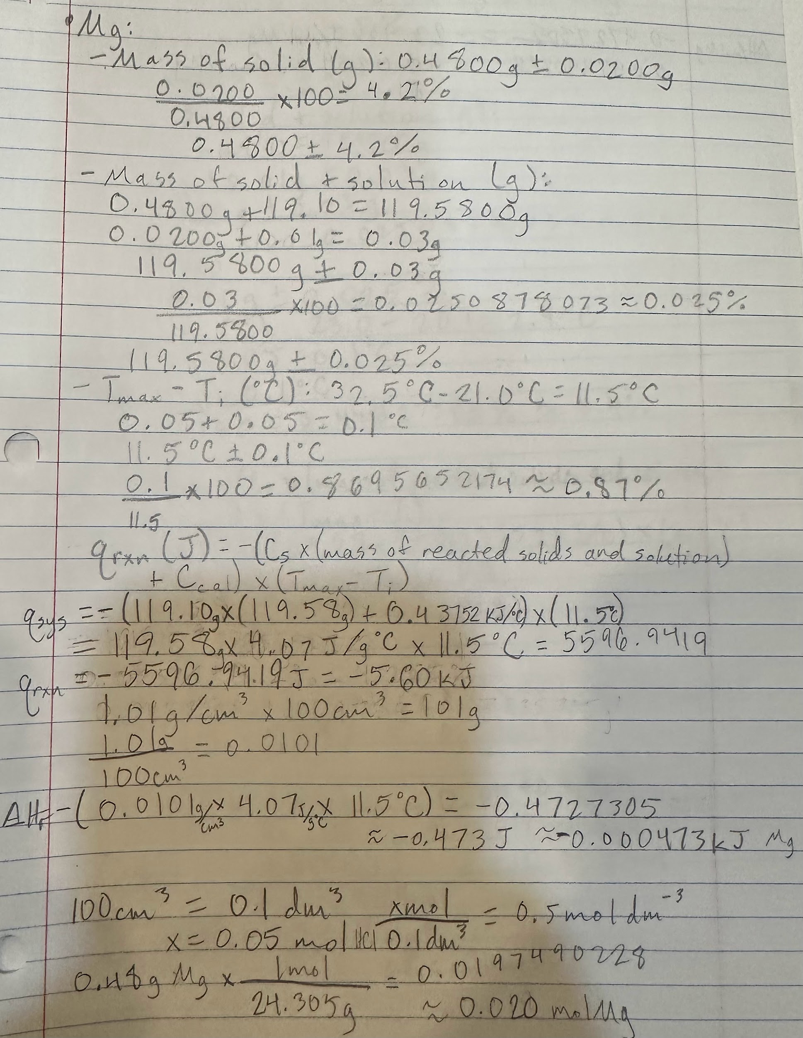
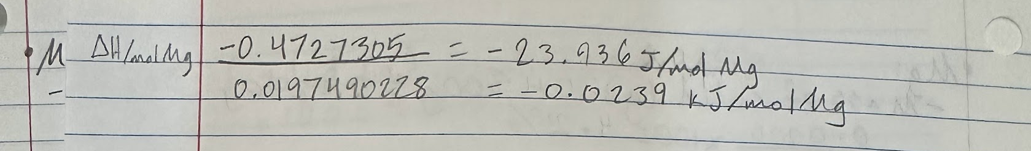
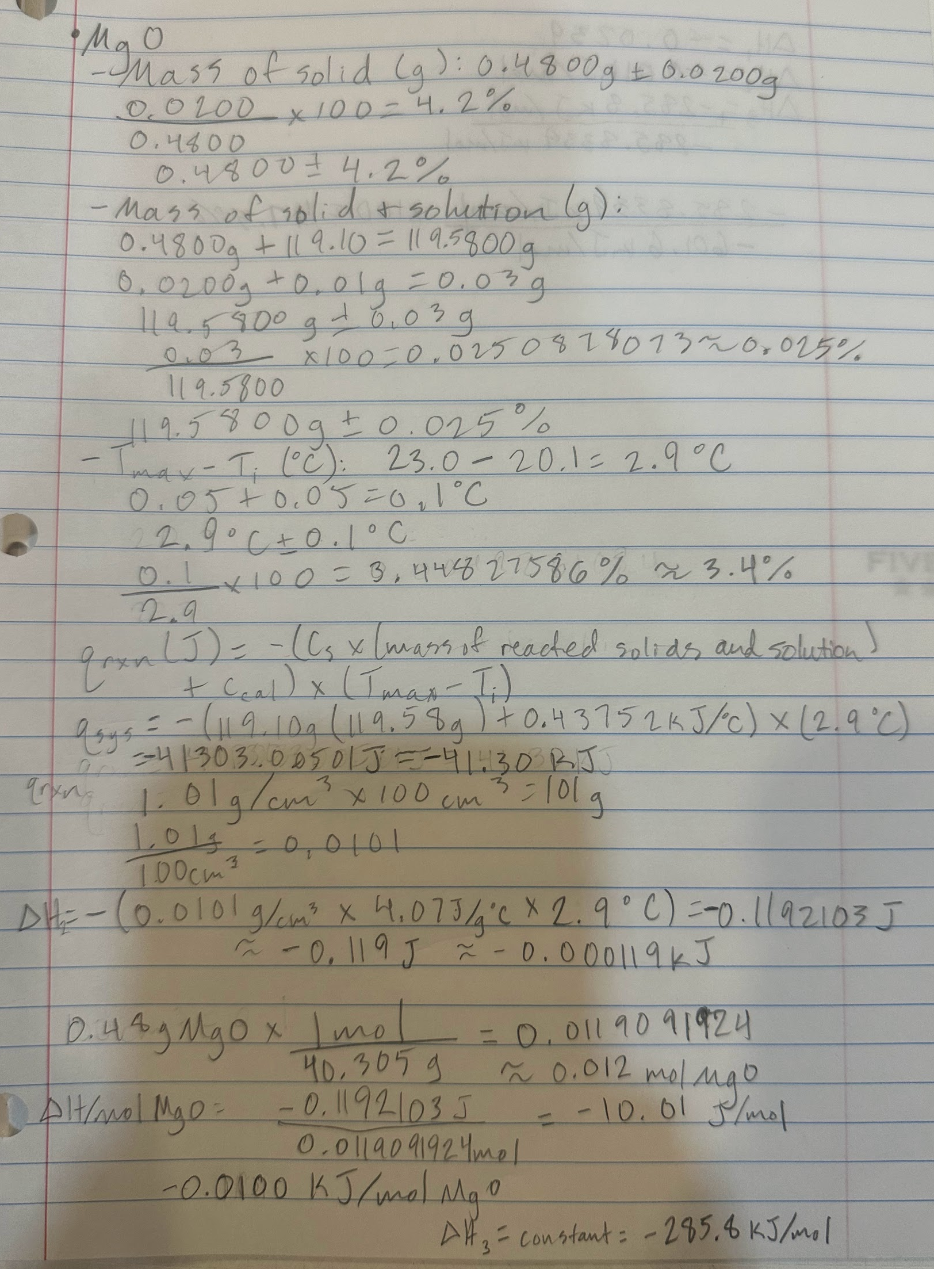
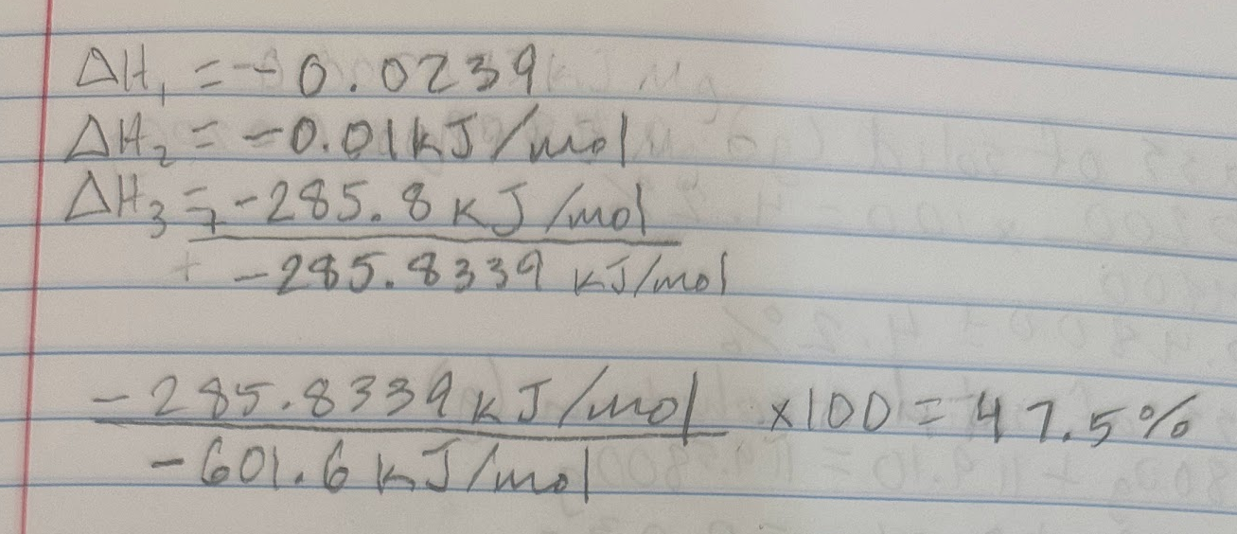
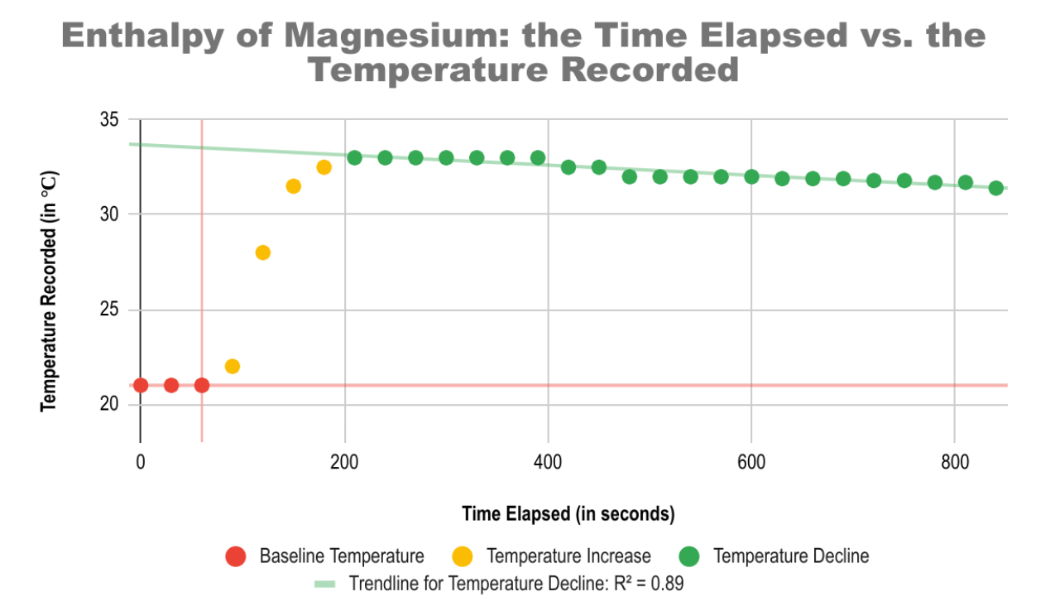
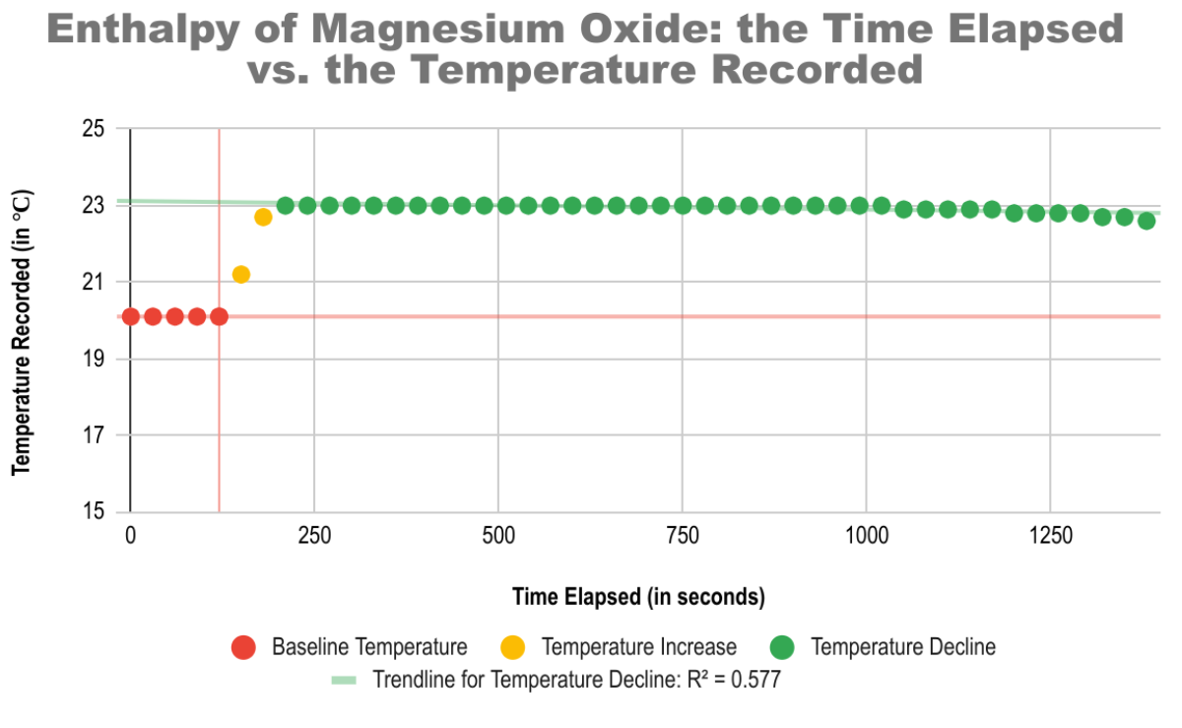
The graphs display the differences between the time it took for the enthalpy reactions to occur for the HCl and Mg reactions and the HCl and MgO reactions. Both have a plateau and a gradual decline after that said plateau, though the trend line for the temperature decline of the MgO reaction is much less notable and took much longer than the temperature decline of the Mg reaction. This is further supported by the fact that the trendline decline for the enthalpy of Mg is R² = 0.89 while the trendline decline for the enthalpy of MgO is R² = 0.577.

Conclusion-
In our experiment, we used calorimeters to mix Mg with HCl as well as MgO with HCl in order to compare the temperature and enthalpy changes between the two reactions. Based on our raw and processed data combined, it is evident that more heat and energy was involved in the reaction between HCl and Mg than in the reaction between HCl and MgO. For instance, the highest temperature in the HCl-Mg reaction was 33.0 ± 0.05 degrees Celsius. However, in the HCl-MgO reaction, the highest temperature was only 23.0 ± 0.05 degrees Celsius. Furthermore, there was a wider range of temperature values in the HCl-MgO reaction (range of about 12 degrees Celsius) than in the other reaction (range just short of 3 degrees Celsius). In addition, the enthalpy of the reaction between Mg and HCl was -0.000473 kJ or -0.0239 kJ/mol Mg. On the other hand, the enthalpy of the reaction between MgO and HCl was -.000119 kJ or -0.0100 kJ/mol MgO. Therefore, the reaction between Mg and HCl released more heat and was more exothermic. Our data and calculations support our hypothesis that the Mg and the MgO being dissolved in HCl would cause an increase in the enthalpy of formation, and that as a result, there would be a temporary and measurable rise in the temperature of the solution.
We compared our data to the accepted scientific context and other findings. What was especially interesting was that our accuracy was quite low. After calculating our enthalpies, we added them together (-.0239 kJ/mol -0.01 kJ/mol - 285.8 kJ/mol) and got -285.8339 kJ/mol. We then took the scientifically accepted third value which the lab had provided, and calculated: (-285.8339 kJ/mol / -601.1 kJ/mol)x100, revealing that our accuracy was 47.5%.
When looking at the graph, it can be observed that the R² value for the MgO trendline is smaller, meaning that the coefficient of determination (what R² represents) for MgO is also smaller. This means that the data may not fit the model as well, in other words, the variables of the experiment aren’t as connected and improvements to the model may need to be made. There can be improvement to the enthalpy of Mg, which has an R² = 0.89, even though it is higher than that of MgO. In conclusion, the observed outcomes are not as well replicated or represented by the scatter plot. This means that analysis of the graph is limited (FreeCode).

Evaluation-
In an enthalpy experiment such as this one, there are many sources of systematic error. One such error was the calibration differences between the two thermometers used in the beginning of the experiment when finding the heat capacity of the calorimeter. One of the thermometers, the purple-tipped one, was 0.5 degrees C higher than the readings of the red-tipped thermometer. This can be mitigated, as we did in our recordings of data, by just adding that difference between the readings to the other readings so they are consistent. In enthalpy reactions in particular, there is a large chance that heat can escape from the calorimeter and lead to a systematic error when measuring the enthalpy changes. While this heat can not be entirely contained, there was an attempt with the hot water calorimeter to contain its heat by doubling up the styrofoam cups used as a calorimeter. This increases the insulation of the apparatus and contains the heat more so than just a single calorimeter.
There are also many sources of random error in an enthalpy experiment, and there were numerous in ours as we were still learning how to operate a calorimeter. The random error we struggled with the most in this experiment is the chance of the reactants having variation in their composition that leads to inconsistent results. The HCl, for example, was not viable when we first tried the second reaction part of the experiment. This resulted in the temperature recorded not dropping after the plateau, which was not supposed to happen. This can entirely throw off the experiment as the reactants must have an accepted composition to be compared to the accepted values given to us in our data booklets (for example). However, we were able to prevent this error somewhat as we identified that the reaction was not acting accordingly and reported it to our lab instructor, who then checked the composition of the HCl.
There was also error present in calculations, as apparatuses such as digital scales can only display a certain amount of decimal places and must round up the values to do so. This results in the weights being displayed not being the true weights of the materials. This percent uncertainty was taken into account with our calculations, but we cannot account for random sources of experimenter-caused data that might’ve appeared without our knowledge. There could have been times when we forgot to tare the digital scale or let the thermometer touch the styrofoam cup itself when recording temperatures. There was also a time when we forgot to put the weigh paper in the water tests of the calorimeter in the beginning. This could affect our temperature readings, but as long as we disclose that (as we did now) and be transparent, our data can still be evaluated properly. Though these random errors are difficult to catch or notice, they can be prevented by diligently checking the instructions of the lab provided.
The extension to this lab that our group would most benefit from would be to calculate more enthalpy reactions, whether that be a repetition of the MgO or Mg enthalpies or other chemical reactions. More similar experiments could be conducted, specifically those that use the calorimeter to practice using Hess’s Law by conducting experiments with reactions that can be added to form that wanted reaction enthalpy. This is a new concept that we need practice with, and that our class would as well, so extensions such as these would be very beneficial. It would also help us have more hands-on experience with how Hess’s Law operates.

Works Cited-
ScienceDirect. (n.d.). Enthalpy. In Biochemistry, Genetics and Molecular Biology. Retrieved from https://www.sciencedirect.com/topics/biochemistry-genetics-and-molecular-biology/enthalpy#:~:text=7.6%20ENTHALPY,H%20=%20%CE%94%20U%20+%20%CE%94%20pV.

Homework Study. (n.d.). Why Does the Calorimeter Have a Heat Capacity? Retrieved from https://homework.study.com/explanation/why-does-the-calorimeter-have-a-heat-capacity.html.

City University of New York. (n.d.). Specific Heat of Copper. Retrieved from https://www.kbcc.cuny.edu/academicdepartments/physci/documents/phy_and_sci/SCI25_SpecificHeatofCopper_Lab3B.pdf.

LibreTexts. (n.d.). Enthalpy of Formation. Retrieved from https://chem.libretexts.org/Courses/Heartland_Community_College/HCC%3A_Chem_161/5%3A_Thermochemistry/5.7%3A_Enthalpy_of_Formation.

Encyclopædia Britannica. (n.d.). Burning Fuels: Overview - Enthalpy. Retrieved from https://www.britannica.com/video/214811/Burning-fuels-overview-enthalpy#:~:text=The%20enthalpy%20of%20a%20reaction%20is%20equal,is%20exothermic%20and%20enthalpy%20will%20be%20negative

Tutor Chase. (n.d.). Why Is the Enthalpy of Formation for Elements Zero? Retrieved from https://www.tutorchase.com/answers/ib/chemistry/why-is-the-enthalpy-of-formation-for-elements-zero#:~:text=By%20definition%2C%20the%20enthalpy%20of%20formation%20of,energy%20change%20involved%20in%20forming%20a%20substance.

Khan Academy. (n.d.). Introduction to Hess's Law. Retrieved from https://www.khanacademy.org/science/ap-chemistry-beta/x2eef969c74e0d802:thermodynamics/x2eef969c74e0d802:hess-s-law/v/hess-s-law-intro#:~:text=Hess's%20law%20states%20that%20if,%CE%94H%20value%20is%20also%20reversed.

Florida State University Department of Chemistry and Biochemistry. (n.d.). Enthalpy. Retrieved from https://www.chem.fsu.edu/chemlab/chm1045/enthalpy.html#:~:text=The%20standard%20enthalpy%20of%20formation%20of%20any%20element%20in%20its,a%20%CE%94HoF%20value.

freeCodeCamp. (n.d.). What is R-Squared (R²) Value? Meaning and Definition. freeCodeCamp. https://www.freecodecamp.org/news/what-is-r-squared-r2-value-meaning-and-definition/#:~:text=R%2DSquared%20(R%C2%B2)%20is,observed%20data%20(dependent%20variable).

