Honors Chemistry— Unit 2: Measurement
BELLRINGERS — SECTION 1: Measurement
Standards: MAFS.912.N-Q.1.1 | MAFS.912.N-Q.1.3 | SC.912.P.12.1 | SC.912.P.12.2
Week of: ______________________ Name: ____________________________________________________ Period: _______
Answer each day’s bellringer in its box. Turn this sheet in at the end of the week.
Day 1 | How would you report the measurement shown in the image? Which digit is estimated?  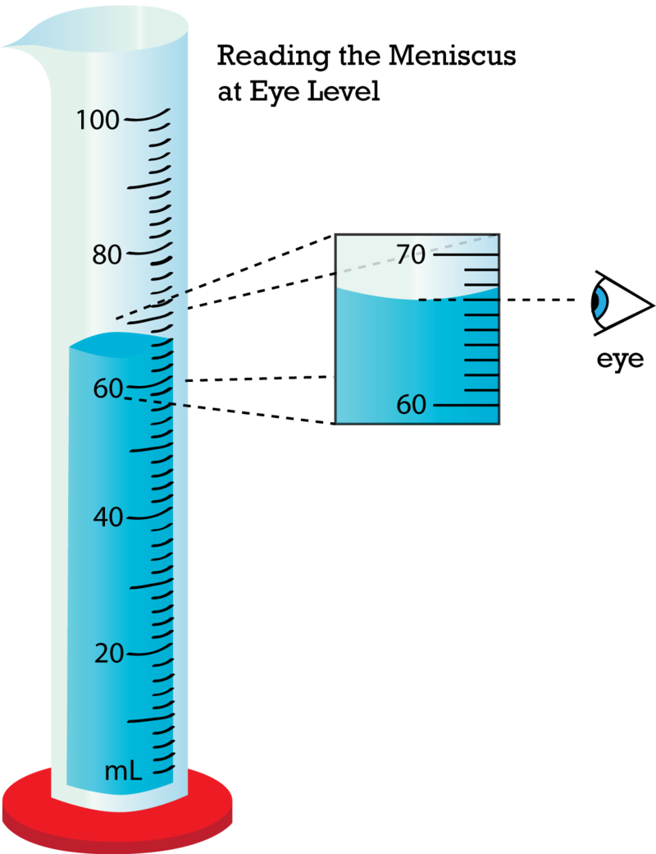
Day 2 | Metric Conversions: Convert with units: (a) the density of an object, 2.15 g/mL → kg/L (b) green light, 5.5 × 10⁻⁷ m → nm (c) 2.5 km → cm.
Day 3 | How many significant figures are in each number? (a) 20.0 mL (b) 0.047 s (c) 6000 kPa vs. 6.0 × 10³ kPa.
Day 4 | A digital balance always reads 0.5 g high. Is that systematic or random error? How would this affect the precision and/or accuracy of your data?
Day 5 | Write your own example of how a data set can be accurate, but not precise. Then write another example of how data can be precise, but not accurate.

